PENETRATION TESTING REPEORT
FOOTPRINTING AND NETWORK SCANNING PHASES
W2-PM-FINAL |CYBERSECURITY |NETWORKWALKS

Pentester Name  (Cybersecurity Professional) | Yvette Ngozi Mefendja
Program Batch | B083-Networkwalks
Date | 16 September 2026
Modules Completed | W2-PM1(Multiple Kali Tools)  W2-PM4(theHarvester scanning)  W2-PM5(Zenmap Scanning)
Client/Target | - Networkwalks (secured written permission already)  - Microsoft.com  3. My own local LAN Network
Permission secured from client | YES
Phases Covered | Phase 1: Reconnaissance & Footprinting  Phase 2: Scanning & Network Discovery

1. Liability Disclaimer
I have performed these activities only on the systems & devices where I secured written permission or the devices/systems that I own myself. All these materials are for education and research purpose only.

2. Introduction
This report covers foot printing of the networkwalks.com domain using multiple Kali Linux tools (W2-PM1) ,theharvester (W2-PM4) on microsoft.com and scanning my own local network with Zenmap (W2-PM5). The two modules which includes theharvester scanning and multiple kali linux tools(whois, dnsrecon,whatweb,curl,wafw00f) covers the footprinting phase and the zenmap covers the scanning phase, so together they show how an attacker moves from gathering public information to mapping live hosts on a network. It is the Week 2 part of my ongoing internship program at Networkwalks.
All commands were run in Kali Linux (footprinting) and on a Windows PC with Zenmap installed (scanning). Every step below includes the exact command used, the result I observed, a screenshot as evidence, and a short note on why the finding matters from an attacker's point of view.

3. Tools Used
The table below lists each tool used in this report and its purpose.
Tool | Purpose
Kali Linux & Windows | Operating systems used for reconnaissance activities
WHOIS | Find domain registration details (owner, dates, name servers).
whatweb | Fingerprint web technologies (server, CMS, plugins, IP).
nslookup | Resolve the domain name to its IP address using DNS.
curl -I | Read the HTTP response headers of the website.
wafw00f | Detect whether a Web Application Firewall protects the site.
dnsrecon | Enumerate all DNS records (NS, MX, SPF, TXT, SRV).
Zenmap (Nmap GUI) | Scan the local subnet to find live hosts, IPs and MAC addresses.
Windows CMD | Local IP and MAC address identification
theHarvester | Gathers information of emails, sub-domain hosts, employee name, open port ,IP addresses from different public source

4. Activities Performed
4.1 Footprinting & Reconnaissance
I performed reconnaissance against the networkwalks.com domain using six Kali Linux tools: whois, whatweb, Nslookup, Curl, Wafw00f and DNSRecon. Each tool was used to collect a different type of information about the target.
First, I used WHOIS to obtain publicly available domain registration information and identify the domain’s name servers. The results provided information about the domain registration and hosting infrastructure.
Then I used WhatWeb to identify technologies used by the website. The results identified WordPress 7.1 and WP Download Manager [3.3.58], HTTPSERVER(Apache), Bootstrap[ 7.1] ,JQUERY[3.7.1], IP address :192.232.216.135 and along with other information exposed by the website.
Using Nslookup, I resolved the domain name to its IP address. The provided result identified 192.232.216.135.

I used Curl with the -I option to inspect the HTTP response headers. This provided additional information about the web application and exposed the WordPress REST API endpoint /wp-json/ and the server.
Next, I used Wafw00f to determine whether a Web Application Firewall was protecting the website. The result identified ModSecurity (SpiderLabs).
Finally, I used DNSRecon to enumerate DNS records. The results provided information relating to name servers, mail servers, SPF/TXT records, service records and DNS software information.

4.2 TheHarvester Scanning. I performed another footprinting scan on Microsoft .com. This tool revealed the email addresses, IPaddresses, sub-domains found in Microsoft .com. This information’s are revealed through different source like baidu, ebay and other related search engineers

4.3 Network Scanning with Zenmap
For the second activity, I used Zenmap to perform network discovery on my local network. The practical required me to identify my local IP address and subnet, discover live hosts, identify their IP and MAC addresses, and generate a network topology.
I first used the Windows ipconfig command to identify my local IP address and LAN subnet. I then entered the subnet into Zenmap and selected Ping Scan to identify active hosts.
The results provided in the practical identified two live hosts:
172.17.155.56
172.17.155.63
MAC addresses were Unavailable.
After completing the scan, I opened the Topology section in Zenmap, enabled the legend and saved the network topology in PDF format as required by the practical task.

5. Risk Analysis / Impact
Based on the information collected during the footprinting and network scanning activities, I identified the following potential risks.
 | Findings | Evidence | Impacts | Risk Level
1 | Server IP address identifiable | The ip address of the domain name was revealed using nslookup [192.232.216.135] | It revealed the network location of the web service | Low
2 | Web technology information exposed | WhatWeb identified WordPress and WP Download Manager | Attackers may use exposed technology/version information to identify software requiring further security review | medium
3 | HTTP information exposed | Curl returned HTTP response headers and exposed /wp-json/ | May assist technology fingerprinting and further enumeration | Low
4 | Firewall technology identified | Wafw00f identified ModSecurity (SpiderLabs) | Reveals information about the web application’s security architecture | Low
5 | DNS infrastructure information exposed | DNSRecon identified DNS, mail and service-related records | It can help in mapping out attack surfaces. | medium
6 | theHarvester  information exposed | reveal email address associated with the domain name, including IPaddress subnet,sub-domains, ASNS and URLS. | it reveals publicly available information that could help someone understand an organization’s external attack surface. | Low
7 | Multiple live hosts visible on local network | Zenmap identified two live hosts in the network | Unknown or unauthorized devices may potentially be present on the network | medium

6. Recommendations
Base on the information gathered from the test, I recommend the following security measures:
- Review whether the web server’s public IP address needs to be directly exposed. Where appropriate, use a reverse proxy/CDN and restrict direct access to the origin server. Ensure firewall rules permit only required traffic.
- Keep WordPress, WP Download Manager, themes, and plugins fully patched and updated. Remove unused plugins/components and avoid exposing unnecessary version information in HTTP responses or page content.
- Review HTTP response headers and disable unnecessary information disclosure. Restrict or properly configure publicly accessible endpoints such as /wp-json/ where they are not required, while ensuring legitimate WordPress functionality is not disrupted.
- Avoid unnecessarily disclosing security-product details through HTTP responses or other externally observable information. Keep ModSecurity rules regularly updated and review WAF logs for suspicious requests.
- Review DNS records and remove obsolete or unnecessary records. Restrict zone transfers to authorized DNS servers, use appropriate DNS security controls, and avoid exposing internal infrastructure through publicly accessible DNS records.
- Review publicly available email addresses, subdomains, IP ranges, ASNs, and URLs. Remove information that is not required to be public and implement controls such as SPF, DKIM, and DMARC for organizational email domains. Provide security-awareness training to reduce phishing and social-engineering risk.
- Identify and inventory the two detected hosts and confirm that each is authorized. Remove or isolate unauthorized devices, segment the network where appropriate, and restrict unnecessary services using host and network firewalls.

7. Conclusion
During Week 2 of my Cybersecurity & Ethical Hacking internship, I completed practical activities covering footprinting, reconnaissance and network scanning.
In the footprinting activity, I used six Kali Linux tools to collect information about the target domain. I learned how WHOIS can provide domain information, WhatWeb can identify web technologies, Nslookup can resolve domain names, Curl can inspect HTTP headers, Wafw00f can identify a WAF, DNSRecon can provide additional DNS information and theHarvester provide email address, sub-domain hosts and other important information from the different public search engines.

In the network scanning activity, I used Zenmap to identify my local network configuration and discover active hosts. I also collected IP and MAC address information and created a network topology.
The exercises showed me that information gathering is an important part of cybersecurity. Even before attempting to exploit a system, a security professional can learn a significant amount about an environment by carefully analyzing publicly available information and network responses.
I also learned that technical findings should be documented clearly and a good cybersecurity report should explain what was performed, what was discovered, what was observed, what risk it may create, and what can be done to reduce that risk.
Finally, I learned that reconnaissance and scanning must always be performed within an authorized scope. These activities were completed as part of the assigned educational cybersecurity lab.
8. Evidences Collected
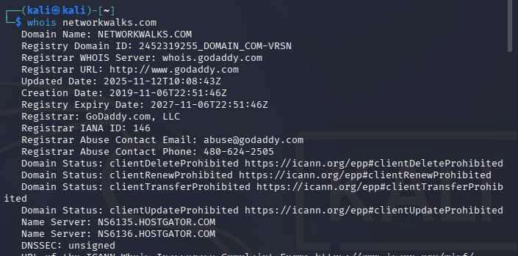
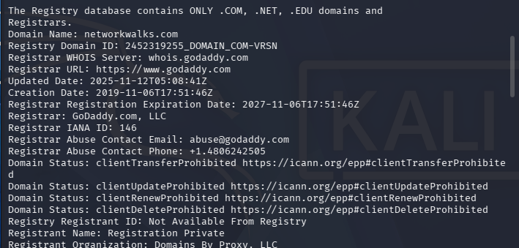
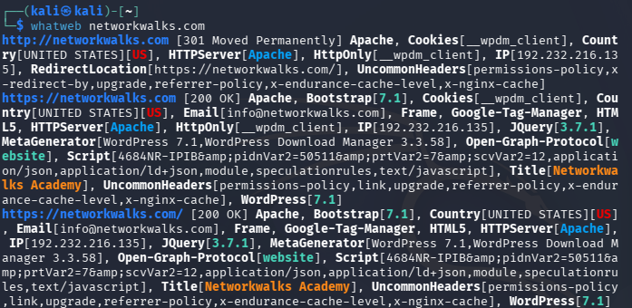
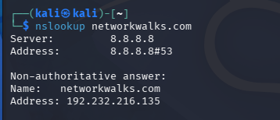
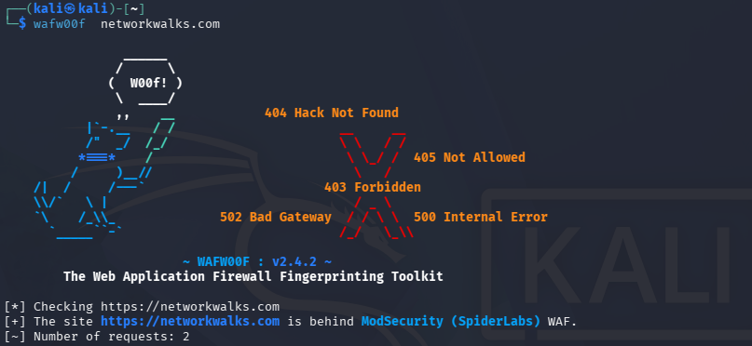
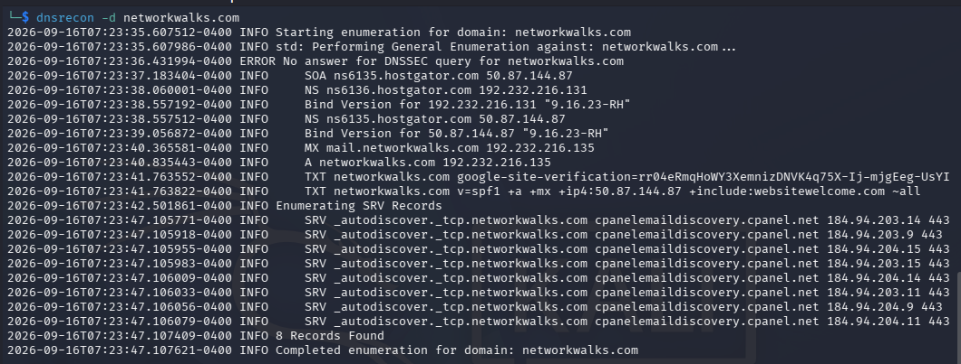
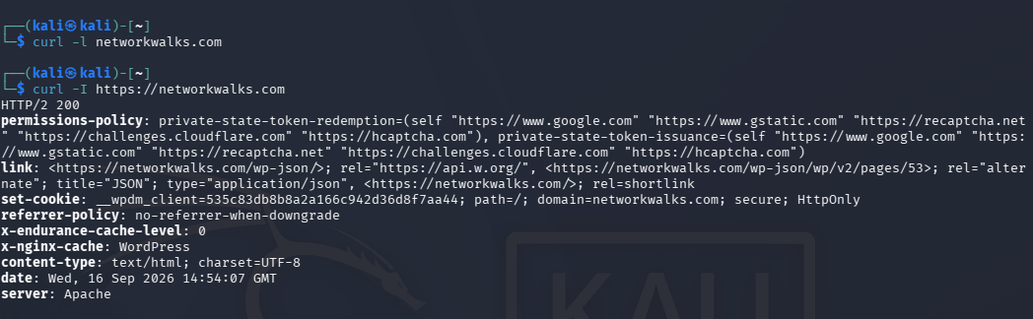
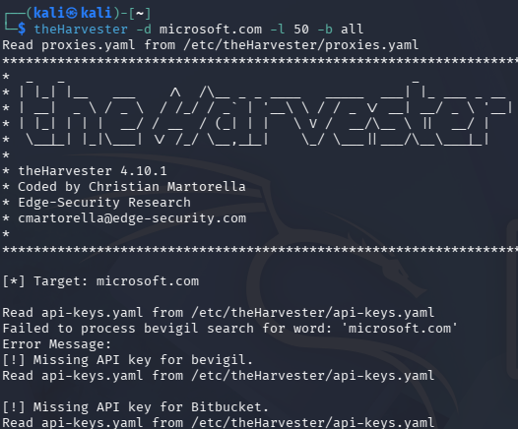
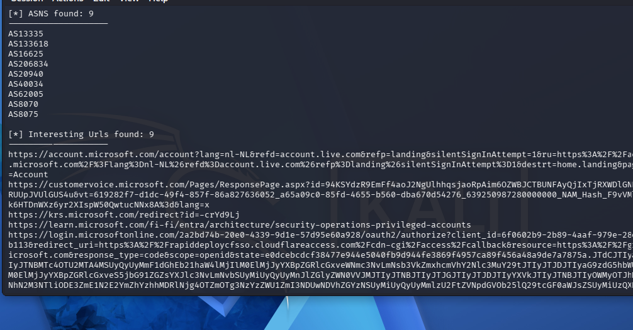
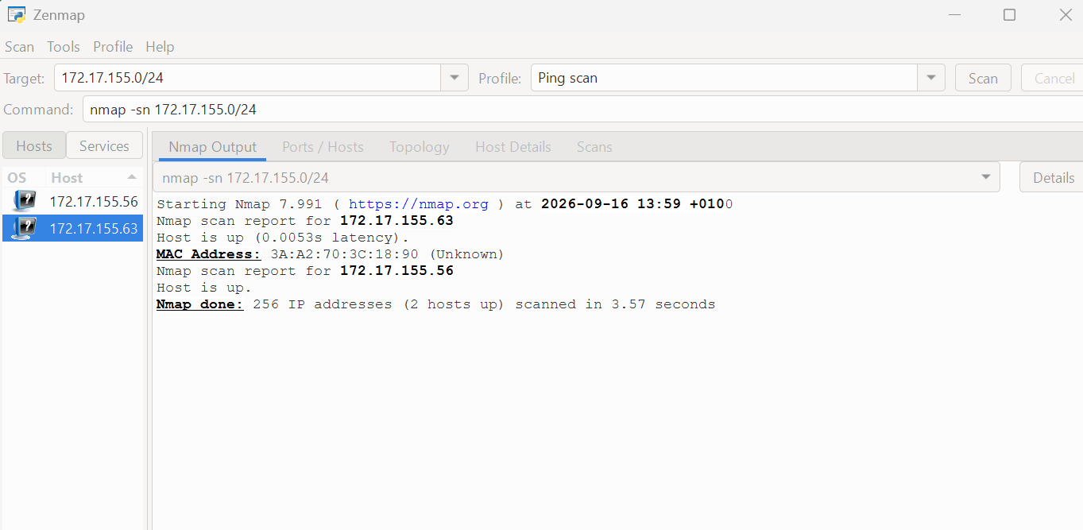
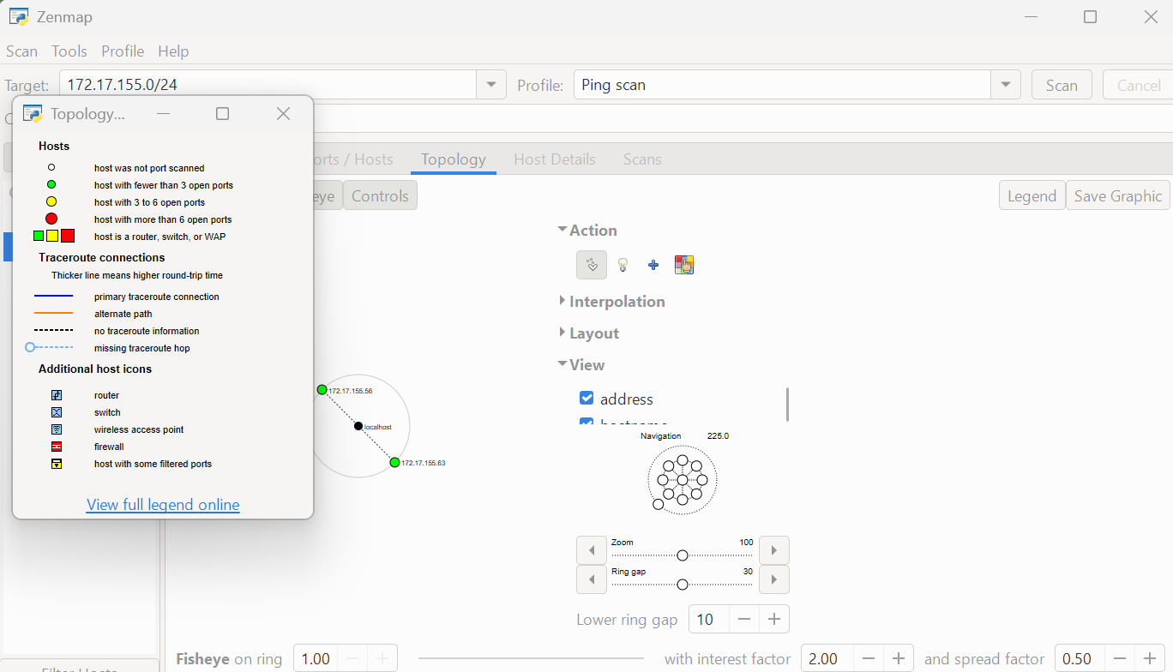

👤 Author
Yvette Ngozi Mefendja
Cybersecurity Professional B083
LinkedIn: www.linkedin.com/in/yvettemefendja

📌 Project Information
Program Name: Cybersecurity program at Networkwalks | Week: 02 | Repository: GitHub

